Storage
Creating Volumes in K8s:-
Two challenges:
- On-disk in a container are ephemeral.
- When there are multiple containers who wants to share same data, it becomes a challenge.
Volumes in K8s:
One of the benefits of K8s is that it supports multiple types of volumes.
EBS
Cinder
Glusterfs
Locsal
nfs
Volume
POD

The above mentioned options are used as volumes but other than that we have wide range of options. For more options for volumes you can visit this K8s volumes Doc Volumes | Kubernetes . In the Doc you can see few of the options are removed and deprecated.
To demonstrate this we are using ‘hostPath’. Usually ‘hostPath’ we can’t explain in digital ocean the tutor is using minikube. Since we are not using Minikube will get the required scripts what he is executing in Mininkube.
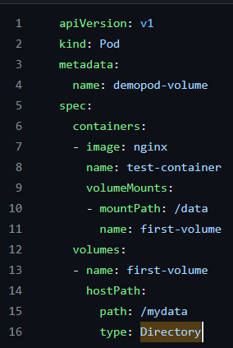
Now first we need to create a directory called ‘/mydata’ in Minikube and then run ‘apply’ command. It will create a POD if you jump into the POD you can see /data folder. If you create a file in /data that it will reflect in the node at /mydata path.
PersistentVolume and PersistentVolumeClaim
Generally developers creates the YAML files associated with pods that they want to deploy.
In a scenario of directly referencing to volumes, developer need to be aware of configurations. Developer should be aware about specific volume types while they mount it to their pods.
Understanding the Challenge:
- I’m a Developer. I just want to write my code and pod.yaml file. I don’t want to take care of storage provisioining , and it’s configs.
- I’m a storage Administrator. I can take care of provisioning storage and its associated configs. Developers can reference the storage within their podspec.
The both scenarios can be achieved through PersistentVolume and PersistentVolumeClaim.
Persistent Volumes:- A persistent Volume (PV) is a piece of storage in the cluster that has been provisioned by an administrator or dynamically provisioned using Storage Classes.
Volume 1 -> Size: Small, Speed: Fast
Volume2 -> Size: Medium, Speed: Fast
Volume 3 -> Size: Big, Speed: Slow
Volume 4 -> Size: VSmall, Speed: Ultra Fast
Volume 5-> Size: Very Big, Speed: Very Slow
- Every Volume which is created can be different type.
- This can be taken care by the Storage Admin/Ops Teeam.
Volume 1 (EBS) -> Size: Small, Speed: Fast
Volume2 (NFS)-> Size: Medium, Speed: Fast
Volume 3 (GlusterFS)-> Size: Big, Speed: Slow
Volume 4 (N)-> Size: VSmall, Speed: Ultra Fast
Volume 5 (Cinder)-> Size: Very Big, Speed: Very Slow
PersistentVolumeClaim:-
A PersistentVolumeClaim(PVC) is a request for the storage by a user. Within the claim, user need to specify the size of the volume along with access mode.
Eg: A Developer requests, I want a volume of size 10 GB which it has speed of Fast for my pod.
Overall Working Steps:-
- Storage Administrator takes care of creating PV.
- Developer can raise a “Claim” (I want a specific type of PV).
- Reference that claim within the PodSpec file.
Hands on:
Since we are not using MiniKube or any Linux server to manage our cluster. We can’t do hands on but still through the scripts we can understand the process.
Now I’m going to create pv.yaml file with the content of.
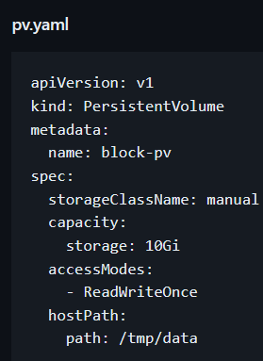
After running ‘apply’ command run ‘kubectl get pv’ to list the ‘pv’.
Now Developer has to raise a “Claim’. For that we will create a ‘pvc.yaml’ file and add the below script.
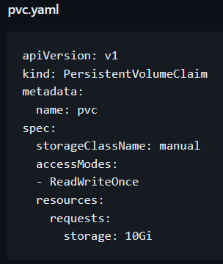
Now you can see pvc by running ‘kubectl get pvc’ .
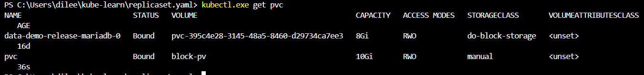
Now if you run ‘kubectl get pv’ you can see that created ‘pv’ has claim. Which it was not there earlier.
Now Developer needs to refer to specific claim.
Now create a file pod-pvc.yaml and add below script.
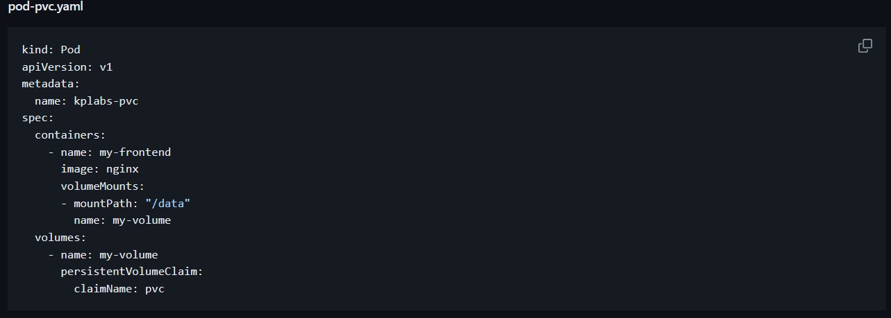
From above script if you see whatever specified in ‘volumeMounts’ that it’s refering to the inside pod that means a ‘mountPath’ with the path ‘/data’ for a volume will be created inside the POD and name of that volume mount is ‘my-volume’
Now in the ‘volumes’ section we will mention the same name ‘my-volume’ and then followed by PVC name that is ‘claimName: pvc’.
Now if you run apply command a POD gets created with the mount path of ‘/data’ and which it will be attached/bind to the nodes filesystem path ‘/tmp/data’.
*** It’s very important do lot of practice on this.
Static Vs Dynamic Provisioning of PV
Types of PV Provisioning:
There are two ways PVs may be provisioned: statically or dynamically.
Types of PV Provisioning | Description
Static | A cluster administrator created a number of PVs.
Dynamic | When none of the static PVs the administrator created matches a user’s PersistentVolumeClaim, the cluster may try to dynamically provision a volume specially for the PVC.

Dynamic: When a Developer raised a claim which he requires 50GB storage volume. But the administer is having two 10GBs in this case it will create the 50GB volume automatically. Here dependency on PV won’t be there.
Hands on:
Create a file with the name of ‘dynamic-pvc.yaml’ and add below script.
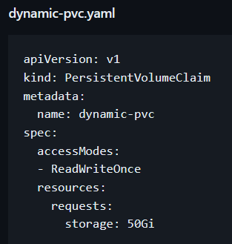
The above script will create a claim with 50GB and it will get automatically claim to PV.
To check this run ‘kubectl get pvc’ and if you see we have removed ‘storageClassName’ that’s why it is showing ‘do-block-storage’
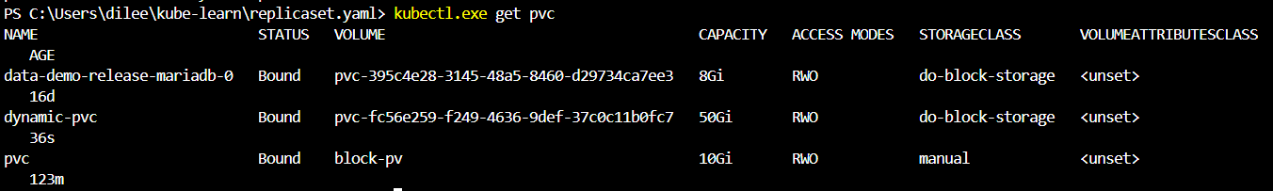
Now if you run ‘kubectl get pv’ you can see in the output that it automatically gets ‘claim’
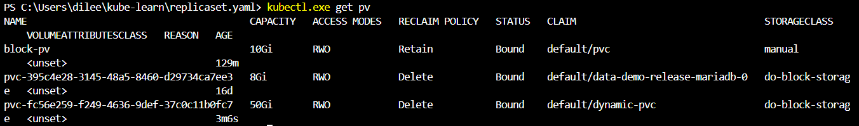
Now if you run describe command it will show Source type and path
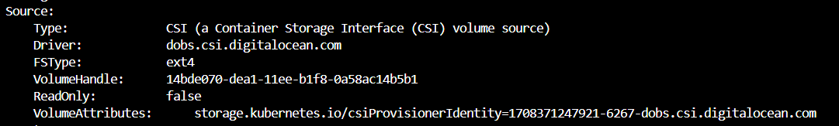
For me volume type is ‘CSI’ and for the tutor it’s ‘HostPath’ *** Need to check is this because of Minikube or not having linux machine which it’s managing the cluster. CSI driver which it’s allocated from Digital Ocean volume.
ConfigMaps
Use-Case:
We have a AppA container and depending on the environment, it’s settings need to be differed.
Eg Properties:
Dev Enivronment: app.env=dev app.mem=2048m app.properties=dev.env.url
Prod Environment: app.env=prod app.mem=8096m app.properties=prod.env.url
Now many organization for above scenario there will build 2 images. But in the future if we want to add more memory at that time again we need to rebuild the entire image. This is a tedious task and this is why we use config maps.
Centrally Store Data:
Instead of hard coding it will store the Data centrally.
App.env=prod
App.mem=8096m
App.properties=prod.env.url

App.env=dev
App.mem=2048m
App.properties=dev.env.url
PROD POD
DEV POD

ConfigMaps

With this we can dynamically add the values let’s assume in the future if you want to add the cpu or increase the memory you can achieve that with the help of ConfigMaps.
So instead of 2 container images we need one image which we can call the configs from centrally stored Data.
CLI Syntax for Creating ConfigMap:-
Kubectl create configmap [NAME] [DATA-SOURCE]
The data source can be 1. File 2. Directory 3. Literal value
Hands on:
Literal:
Let’s create a configmap ‘app.mem=2048m’
To list ‘kubectl get configmap’
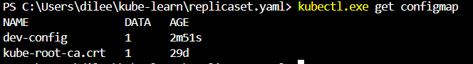
File: If you have hundreds of configuration we will refer to the file.
For simple purpose we are going to create dev.properties and going to add below properties.
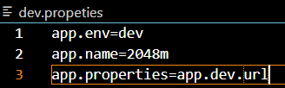
Now run “kubectl.exe create configmap dev-properties --from-file=dev.propeties”
Now if you run -o yaml it will show the properties assigned to that configmap
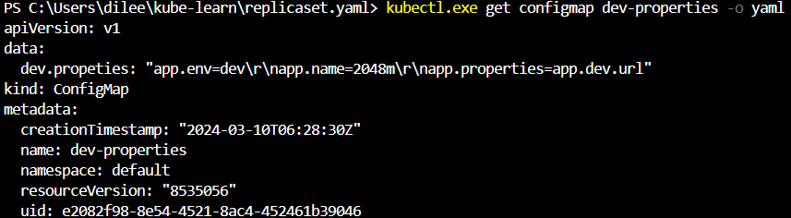
Directory: If you have files we will use the directory
Now, the next aspect is how you can mount this config map which has been created inside a pod.It’s important whenever you do a restart automatically these configs needs to get attach to it.
One of the standard ways, which is used very extensively is through volumes.
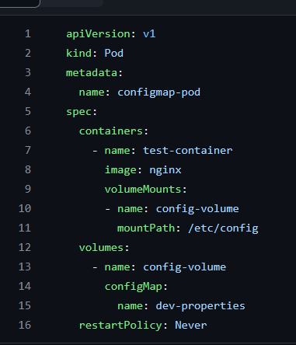
If you see above script under ‘volumes’ the ‘configMap’ the ‘name’ will be the one which we have to give the configMap name that is ‘dev-properties’. The properties whatever we defines in ‘dev-properties’ it will be configure in inside the path of ‘/etc/config’.
Now after apply command you can see the ‘dev.propeties’ file inside the pod inside the ‘/etc/config’ path.
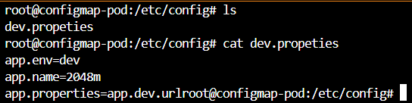
*** Important
Security Context
Challenge:-
When you run a container, it runs with the UID 0 (Administrative Privilege).
In case of container breakouts, attacker can get root privileges to your entire system.
In this case, we can run the POD and container with limited privilege user instead of the ROOT user.
Three Important Permission Aspects:-
SecurityContext | Description
runAsUser | Specifies the user of the running processes in continaers
runAsGroup | Specifies the primary group for all process within containers.
fsGroup(fs=filesystem) | Applies the settings to the volumes.  Volumes which support ownership management are modified to be owned and writable by the GID specified in fsGroup
If you run any command inside the POD it will execute this with root privilege. To overcome this we need to define few values like user and group in the YAML file for a pod. See below script.
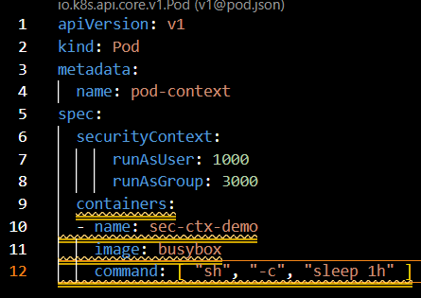
If you see above script the POD will be created with User 1000 and with the group 3000. If you run any command it will not run with ROOT privilege.
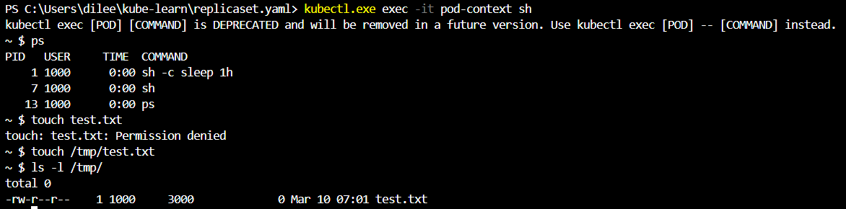
From the above SS you can see after creating a file inside the POD If you do ‘ls -l’ it will be showing the user 1000 and the group as 3000.
fsGroup:-
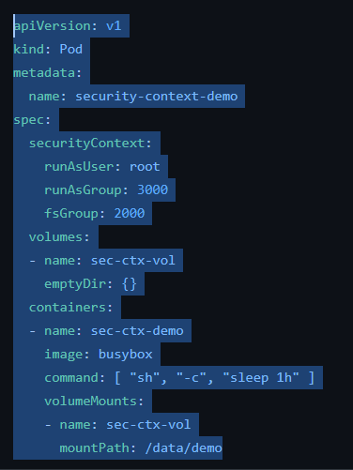
From above script if we create a file inside and run ‘ls -l’ it will show the user name and group name as 1000 and 3000 but if you create any file under /data/demo path it will be having username and group name as 1000 and 2000.
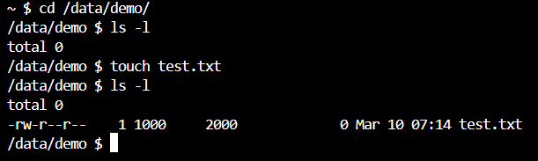
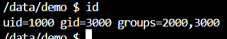
Storage Volume Expansion
Challenge: It can happen that your persistent volume has become full and you need to expand the storage for additional capacity.
Step1- Enable Volume Expaansion
Enabling Volume Expansion in the storage class i.e “allowVolumeExpansion”:”true”
Step2-Resizing the PVC
Step3- Restart the POD
- Once PVC object is modified, you will have to restart the POD.-> Kubectl delete pod [POD NAME] -> kubectl apply -f pod-manifest.yaml
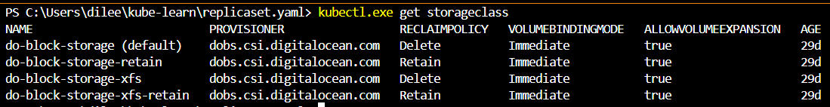We have a provisioner of digitalocean.
Now, as a part of step1 we need to check the “allowVolumeExpansion”:”true” is there are not for that we need run ‘kubectl get storageclass do-block-storage -o yaml’ after running it then verify the value is true or false once it’s true we will move to step2 that is increasing the size in pvc.
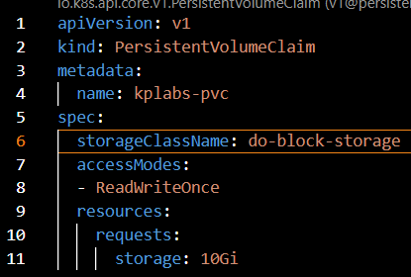
After apply command.
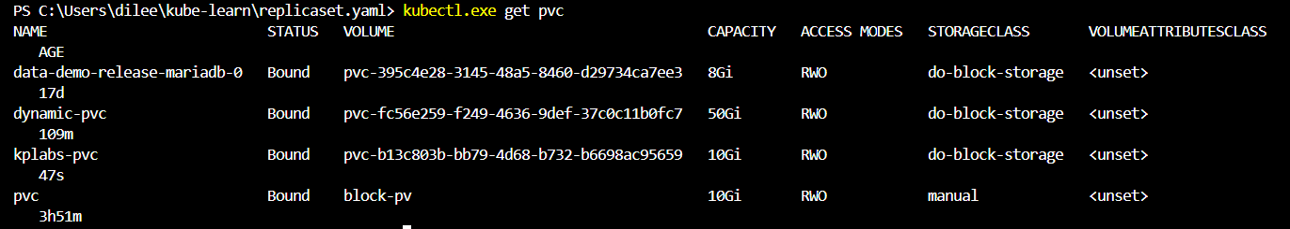
Now we need to create a pod
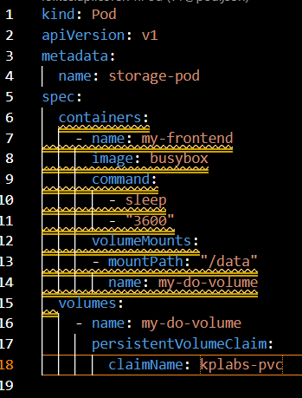
After apply command if you do pod describe you can see the events message volume has been attached to the POD successfully
Now if you jump into the and do ‘df -h’ you can see the attached volume which is highilighted in the below SS
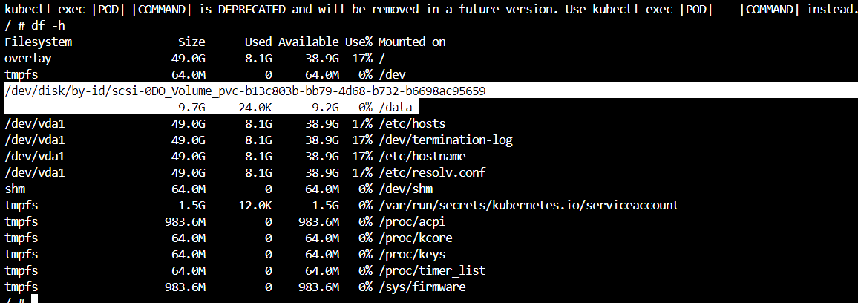
Now We want to expand the storage let’s assume from 10GB to 12GB.
To do that run ‘kubectl edit pvc kplabs-pvc” It will open an editor tool change the storage size from 10 to 12 and then save it.
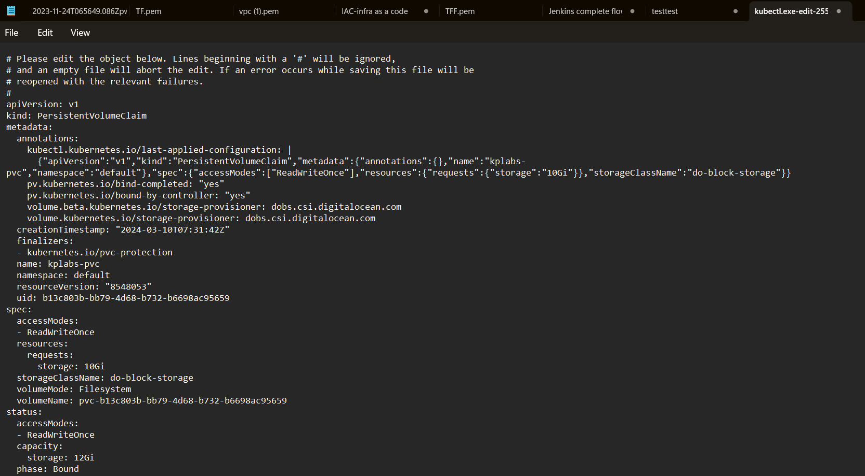
Now if you do “kubectl.exe get pvc kplabs-pvc -o yaml” it will show a message “message: Waiting for user to (re-) start a pod to finish file system resize of volume on node”.
Anyway if you do ‘kubectl get pv’ it will show storage as 12GB but in the pod still it will show 1o GB only if you restart the pod then only you can see the size of 12GB.

